7 FOOD COURT ORDERING SYSTEM

Table of contents

**1. Java Installation 1-4**

**2. NetBeans Installation procedure 5-10**

**3. Add mysql jdbc driver 10**

**4****. Install MySQL** **11-24**

**5. 7 food court ordering system 25-35**

1.Introduction

2.Objectives

3.Scopes

4.Project procedure

### **1. How To Install JDK on Windows**

##### **Step 0: Un-Install Older Versions of JDK/JRE**

I recommend that you install only the *latest* JDK. Although you can install multiple versions of JDK/JRE concurrently, it is messy.

If you have previously installed older versions of JDK/JRE, un-install ALL of them. Goto "Control Panel" ⇒ "Programs" ⇒ "Programs and Features" ⇒ Uninstall ALL programs begin with "Java", such as "Java SE Development Kit ...", "Java SE Runtime ...", "Java X Update ...", and etc.

##### **Step 1: Download JDK**

1. Goto Java SE download site @<http://www.oracle.com/technetwork/java/javase/downloads/index.html>.
2. Under "Java Platform, Standard Edition" ⇒ "Java SE 8u{xx}", where {xx} is the latest update number ⇒ Click the "JDK Download" button.
3. Look for the latest "Java SE Development Kit 8u{xx}" ⇒ Check "Accept License Agreement".
4. Choose the JDK for your operating system, e.g., "Windows x64" (for 64-bit Windows OS) or "Windows x86" (for 32-bit Windows OS). You can check whether your Windows OS is 32-bit or 64-bit via "Control Panel" ⇒ (Optional) System and Security ⇒ System ⇒ Under "System Type".

##### **Step 2: Install JDK and JRE**

Run the downloaded installer (e.g., "jdk-8u{xx}-windows-x64.exe"), which installs both the JDK and JRE. By default, the JDK will be installed in directory "C:\Program Files\Java\jdk1.8.0_xx", where xx denotes the upgrade number; and JRE in "C:\Program Files\Java\jre1.8.0_*xx*".

Accept the defaults and follow the screen instructions to install JDK and JRE.

Check the JDK installed directory by inspecting these folders using File Explorer. Take note of your JDK installed directory, in particular, the upgrade number, which you will need in the next step.

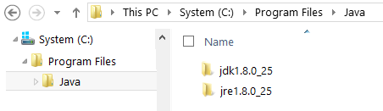

I shall refer to the JDK installed directory as <JAVA_HOME>, hereafter, in this article.

##### **Step 3: Include JDK's "bin" Directory in the PATH**

Windows Shell searches the current directory and the directories listed in the PATH *environment variable* (*system variable*) for executable programs. JDK's programs (such as Java compiler javac.exe and Java runtime java.exe) reside in directory "<JAVA_HOME>\bin" (where <JAVA_HOME> denotes the JDK installed directory). You need to include "<JAVA_HOME>\bin" in the PATH to run the JDK programs.

To edit the PATH environment variable in Windows 7/8/10:

1. Launch "Control Panel" ⇒ (Optional) System and Security ⇒ System ⇒ Click "Advanced system settings" on the left pane.
2. Switch to "Advanced" tab ⇒ Push "Environment Variables" button.
3. Under "System Variables" (the bottom pane), scroll down to select "Path" ⇒ Click "Edit...".
4. **For Windows 10 (newer releases)**:
5. You shall see a TABLE listing all the existing PATH entries (if not, goto next step). Click "New" ⇒ Enter the JDK's binary directory "c:\Program Files\Java\jdk1.8.0_xx\bin" (Replace xx with your installation number!!!) ⇒ Select "Move Up" to move this entry all the way to the TOP.
6. **Prior to Windows 10**:
7. **(CAUTION: Read this paragraph 3 times before doing this step! Don't push "Apply" or "OK" until you are 101% sure. There is no UNDO!!!)**
8. (To be SAFE, copy the content of the "Variable value" to Notepad before changing it!!!)
9. In "Variable value" field, INSERT "c:\Program Files\Java\jdk1.8.0_xx\bin" (Replace xx with your installation number!!!) IN FRONT of all the existing directories, followed by a semi-colon (;) which separates the JDK's binary directory from the rest of the existing directories. DO NOT DELETE any existing entries; otherwise, some existing applications may not run.
10. Variable name : **PATH**  
    Variable value : **c:\Program Files\Java\jdk1.8.0_xx\bin;[*exiting entries...*]**

My Notes: Starting from JDK 1.8, the installation created a directory "c:\ProgramData\Oracle\Java\javapath" and added to the PATH. It contains only JRE executables (java.exe, javaw.exe, javaws.exe) but NOT the JDK executables (e.g., javac.exe).

##### **Step 4: Verify the JDK Installation**

Launch a CMD shell via one of the following means:

1. Click "Search" button ⇒ Enter "cmd" ⇒ Choose "Command Prompt", or
2. right-click "Start" button ⇒ run... ⇒ enter "cmd", or
3. (Prior to Windows 10) click "Start" button ⇒ All Programs ⇒ Accessories (or Windows System) ⇒ Command Prompt, or
4. (Windows 10) click "Start" button ⇒ Windows System ⇒ Command Prompt

Issue the following commands to verify your JDK installation:

1. Issue "path" command to list the contents of the PATH environment variable. Check to make sure that your <JAVA_HOME>\bin is listed in the PATH.
2. Don't type prompt>, which denotes the command prompt!!! Key in the command (highlighted) only.
3. // Display the PATH entries  
   prompt> **path**  
   PATH=**c:\Program Files\Java\jdk1.8.0_xx\bin**;[*other entries...*]
4. Issue the following commands to verify that JDK/JRE are properly installed and display their version:
5. // Display the JRE version  
   prompt> **java -version**  
   java version "1.8.0_xx"  
   Java(TM) SE Runtime Environment (build 1.8.0_xx-b13)  
   Java HotSpot(TM) 64-Bit Server VM (build 25.5-b02, mixed mode)  
      
   // Display the JDK version  
   prompt> **javac -version**  
   javac 1.8.0_xx

1.Installation Procedure

1.Netbeans 8.2 installation process

## **First We Need Required Software for developing project**

The Java SE Development Kit (JDK) 8 is required to install NetBeans IDE. You can download the latest update of java development Toolkit (JDK8) is require to install netbeans. atThe PHP and C/C++ NetBeans bundles only require the Java Runtime Environment (JRE) 8 to be installed and run. JDK 8 is required if you are planning to use any of the Java features.

JDK 8 is required to use JavaFX 8 features in NetBeans IDE 8.2.

Note:

* JavaFX 8 is bundled with JDK 8 for Windows, Mac and Linux.
* Unlike previous versions of NetBeans IDE, NetBeans IDE 8.2 does not require that you set up an "FX-enabled" Java platform in order to utilize JavaFX support in the IDE. You can develop JavaFX projects in the IDE if you install JDK 8.
* To use JavaFX features in NetBeans IDE, we strongly use that you use JDK 8.

## Downloading options:<https://netbeans.org/downloads/>

On the NetBeans IDE Download page, you can obtain one of several installers, each of which contains the base IDE and additional tools.

The following installers are available:

* Java SE. Supports all standard Java SE development features as well as support for NetBeans Platform development and JavaFX 2.2 SDK (or newer) or JavaFX 8 SDK.
* Java EE. Provides tools for developing Java SE and Java EE applications as well as support for NetBeans Platform development and JavaFX 2.2 SDK (or newer) or JavaFX 8 SDK. This download option also includes GlassFish Server Open Source Edition 4.1.1, and Apache Tomcat 8.0.27 software.
* HTML5/JavaScript. Provides tools for HTML5/Javascript development. Includes Java Runtime Environment and does not require a separate Java installation.
* PHP. Provides tools for PHP 7 development, Zend and Symfony Framework support. Includes Java Runtime Environment and does not require a separate Java installation.
* C/C++. Supports development in the C, C++, Qt, Fortran and Assembly languages. Includes Java Runtime Environment and does not require a separate Java installation.
* All. This is a full download option, which contains all the runtimes and technologies available for the NetBeans IDE.

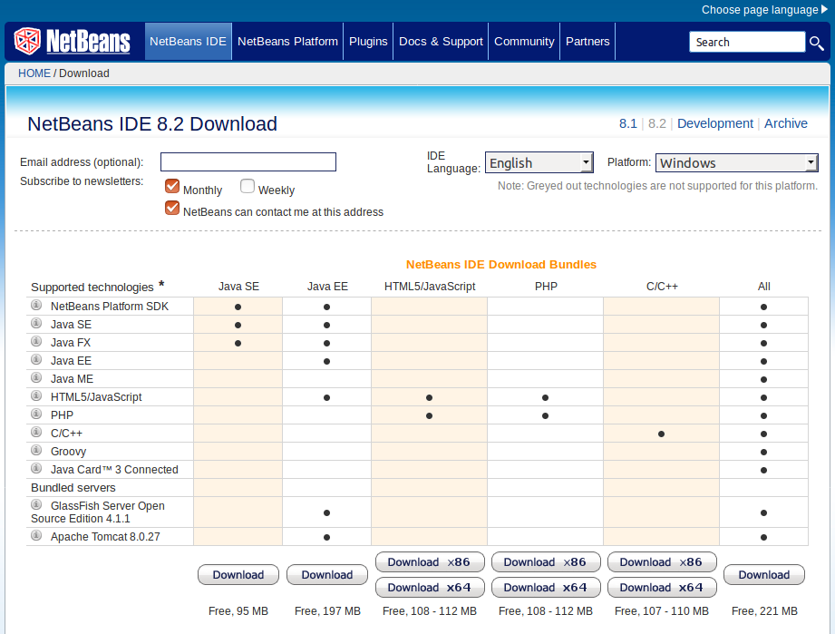

* We need to download all supported platforms,which means all the runtime and

Technologies available for the netbeans IDE.

* Total 214 MB is required to download Netbeans.
* After completion of netbeans Download ,It can be saved as a downloads .
* By using command prompt we have to install the Netbeans 8.2 software
* After completion of Running the installer wizard..It can be show can as like This..

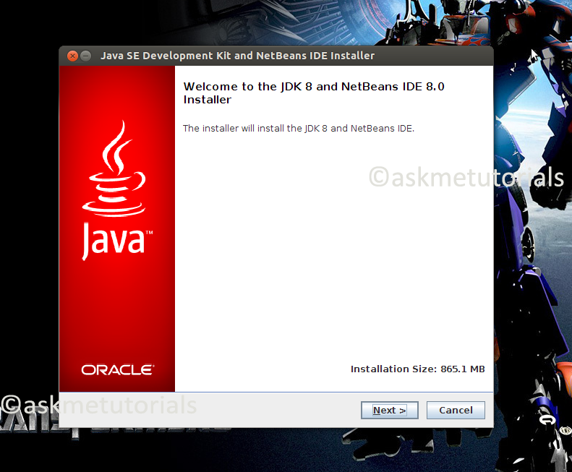

We click on Next button

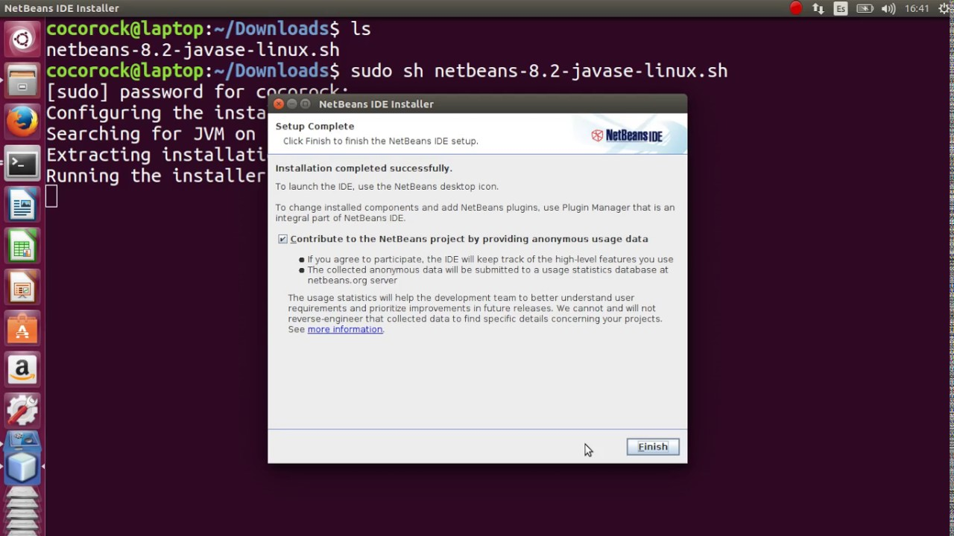

After completion of installation we click on finish button

Take a sample project

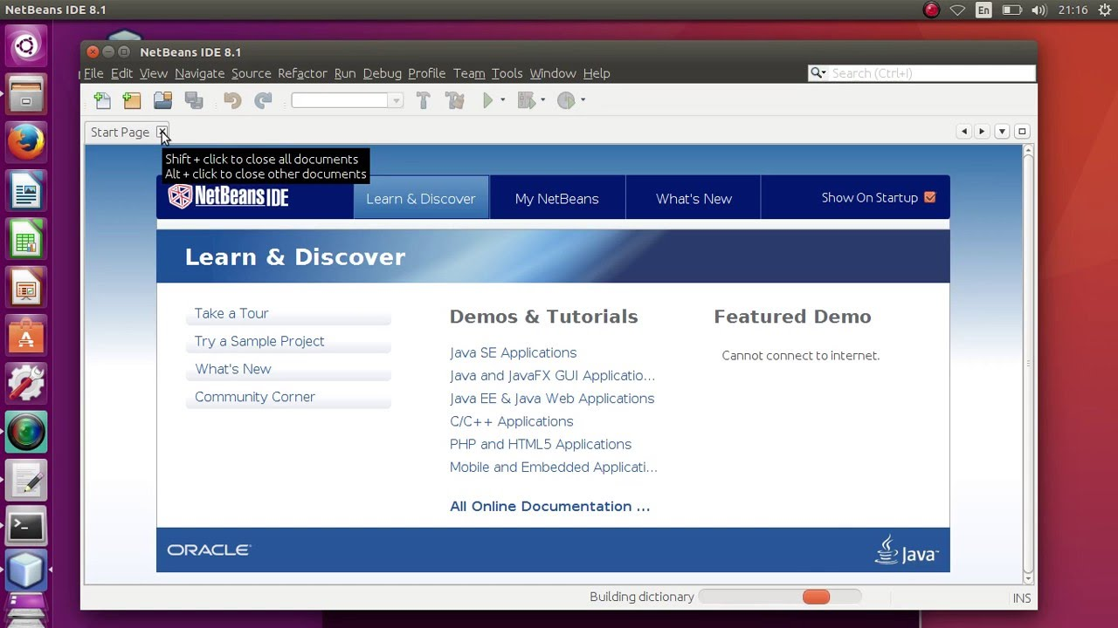

Create a Java Project

Open the NetBeans IDE and create a Java Project in the following manner:

File → New Project; a window will appear. Select *Java* from the Categories list and *Java Application* from the Projects list. Click Next.

In the New Java Application window, enter the name location of the project. Optionally, check *Use Dedicated Folder for Storing Libraries Or* un-check it. It does not matter, at least for our current project, but the purpose is clearly stated in the help section; let's not restate it here.

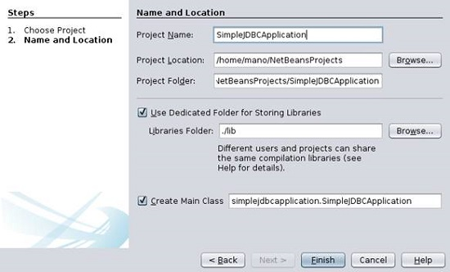

**1: Assigning a project name and location**

We click on Finish button . This will create a Java project environment in NetBeans.

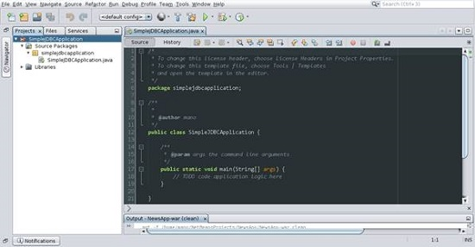

**2.Add the MySQL JDBC Driver**

Because it is a JDBC project and we opt to connect to a MySQL database, we need MySQL JDBC Driver. It is basically a vendor-specific Type 4 driver that bridges the communication gap between our application and the database. If you want to connect to any other database, look for that database-specific JDBC driver. A JDBC Driver for almost all major databases (Oracle, PostgreSQL, and so on) is available in the relevant vendor sites.

* Right-click the project name in the Projects tree view → Properties.
* Select Libraries from the Categories Tree .

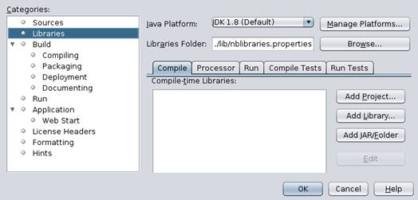

**3: Selecting Libraries from the Categories tree view**

* Click the Add Library button. An *Add Library* window will appear. If the MySQL JDBC
* Driver is not present in the available libraries list, click the Import…button. Then, click the MySQL JDBC Driver from the available libraries list.

**4: Adding a Library**

If the import is successful, the imported jar file will be shown in the projects list.

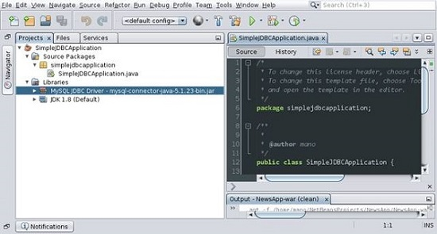

The imported jar file is shown in the projects list

**3.Install MySQL**

**Procedure:**

* Download MySQL 5.1 for Windows
* You can download version 5.1 from this page [Download MySQL 5.1](http://www.mysql.com/downloads/mysql/5.1.html)
* Or download the latest MySQL version [here](http://dev.mysql.com/downloads/mysql/).
* For archives of various MySQL versions, [click here](http://downloads.mysql.com/archives.php).
* You click on [Download MYSQL 5.1](https://dev.mysql.com/downloads/mysql/)
* For more details click on below link <https://www.youtube.com/watch?v=WuBcTJnIuzo&t=1205s>

<https://dev.mysql.com/downloads/mysql/5.1.html>

It can be show as

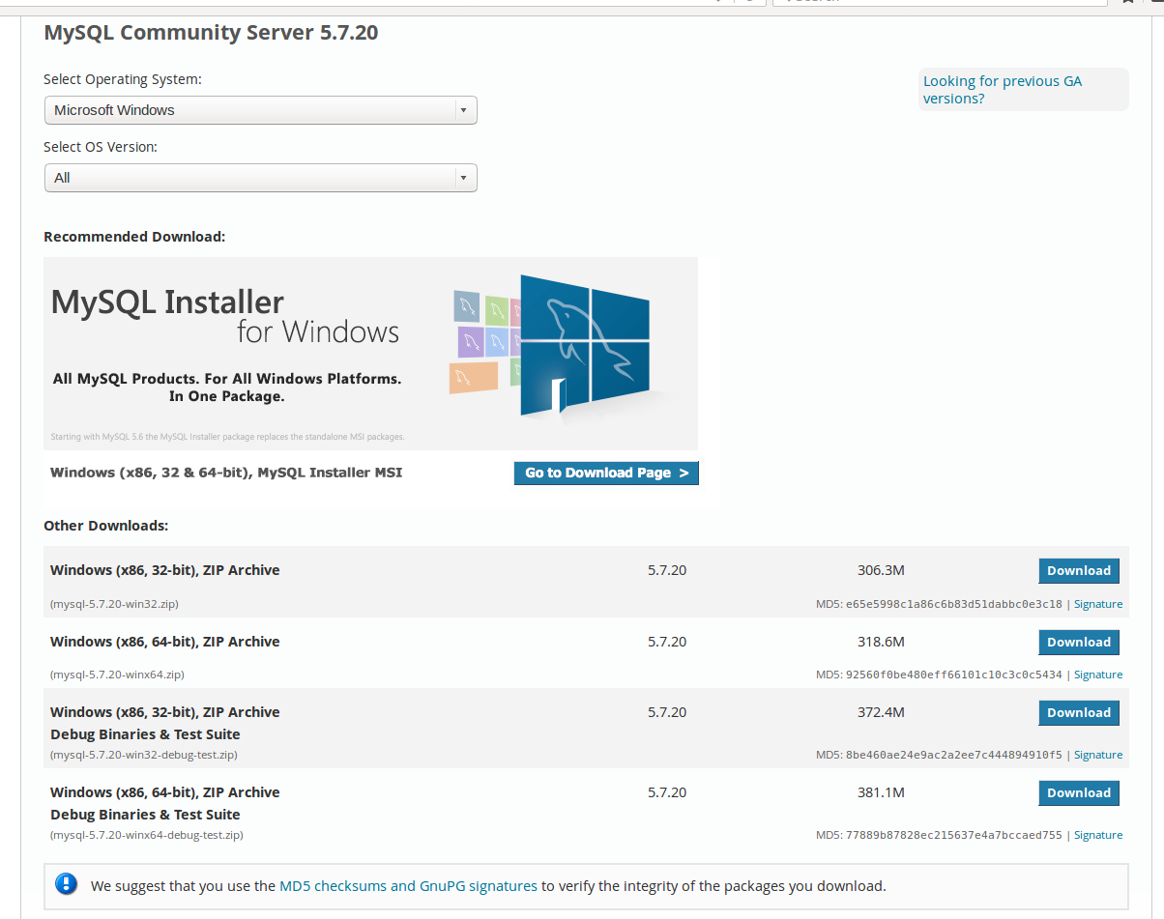

**Install MySQL**

Double click the MSI installer to start installing MySQL. You will go through a setup

wizard so it's fairly simple. Just follow the installation instructions step by step.

**(1) Welcome to the Setup Wizard for MySQL Server 5.1.**

Click Next to continue.

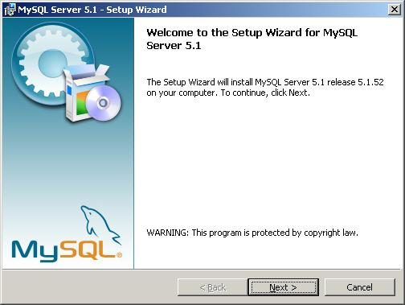

**(2) Select a setup type**

-> Typical, Complete, Custom.

Select complete and click Next.

The default installation directory will be C:\Programs Files\MySQL\MySQL Server 5.0\

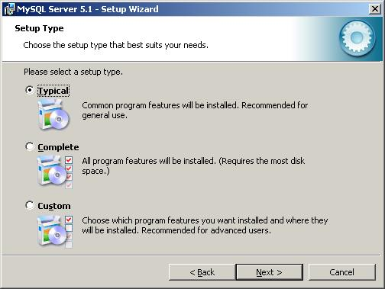

**(3) Ready to install MySQL.**

After review the settings, click Install. If you want to change any settings, click [Back] button.

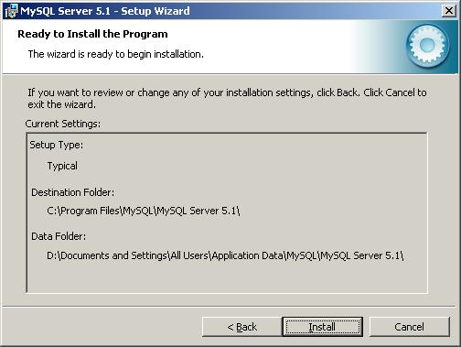

**(4) Installation in progress.**

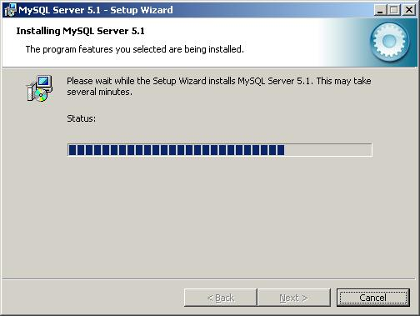

**(5) More information about MySQL Enterprise Subscription.**

This step is just an informational step for MySQL Enterprise Subscription. Click the

[More...] button if you want to know more. Otherwise, click [Next] to go to next step.

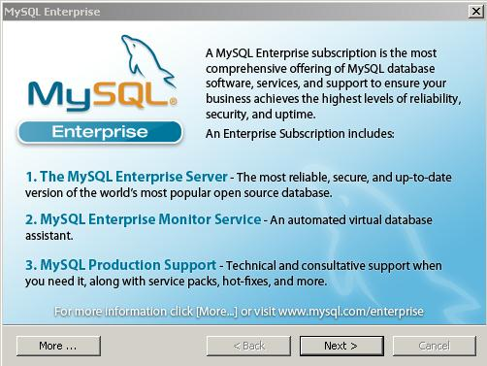

**(6) Setup Wizard Completed.**

Make sure you have selected 'Configure the MySQL Server now' checkbox if you want to

configure it after clicking Finish button.

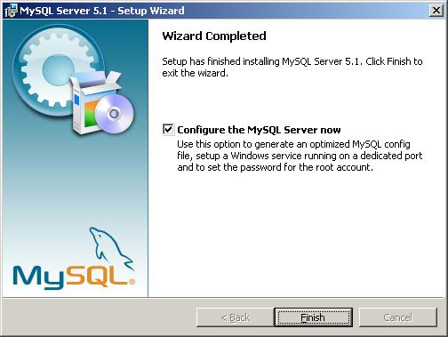

[**How to configure MySQL server 5.1 on Windows**](http://www.geeksengine.com/article/configure-mysql-v5.html)

[After installing MySQL 5.1 on Windows](http://www.geeksengine.com/article/install-mysql-v5.html),

we will need to configure it. This article provides step-by-step MySQL server 5.1 configuration guide on Windows as a development box.

If you want to install multiple versions of MySQL on the same box, read this article [How to install two different versions of MySQL on the same computer](http://www.geeksengine.com/article/install-two-mysql.html) for more info.

**1. Start MySQL Server Instance Configuration Wizard.**

If you have selected the checkbox 'Configure the MySQL Server now' in the last step when [installing MySQL 5.1](http://www.geeksengine.com/article/install-mysql-v5.html), the configuration wizard should start automatically when you click the Finish button.

Alternatively, you can launch the wizard from Start menu. Start -> Programs -> MySQL -> MySQL Server 5.1 -> MySQL Server Instance Config Wizard.

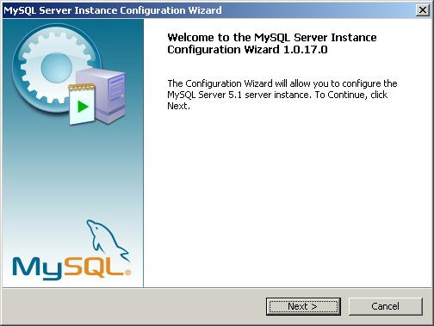

**2. Select configuration type.**

Select Detailed Configuration here. If this is the only MySQL server installed on your computer, you can select Standard Configuration.

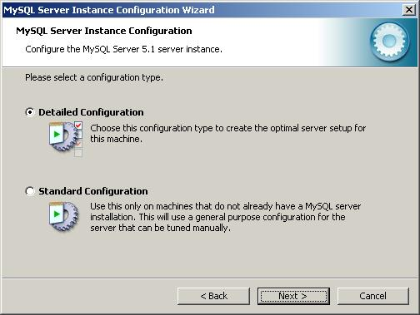

**3. Select a server type.**

As this MySQL server is running on a development box, select Developer Machine as the server type.

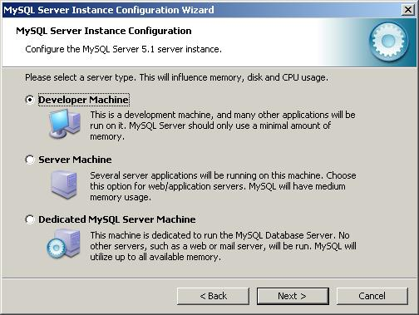

**4. Select the database usage.**  Depends on the purpose of your development box, you can select either Multifunctional Database or Transactional Database Only.

Here we selected Transactional Database Only.

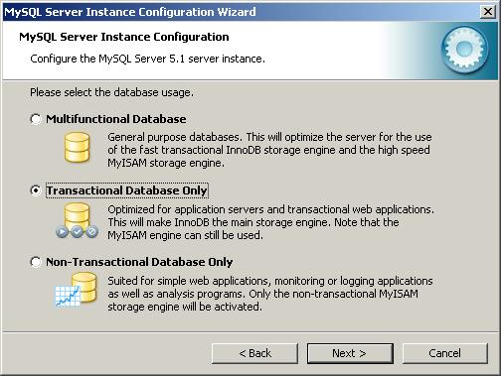

**5. Set InnoDB tablespace settings**.

InnoDB table type is the storage engine for a transactional database. Use the default settings here.

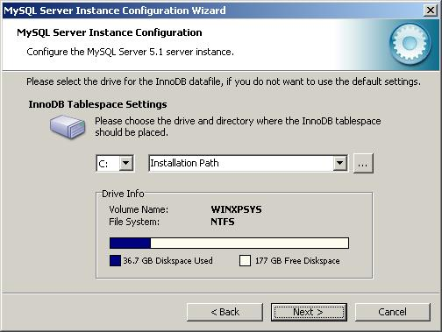

**6. Set the database engine's concurrent connections option.**

Here we selected Online Transaction Processing (OLTP) as it is the most common use of MySQL server.

If the MySQL server on your development machine is used for decision support such as data warehousing or data mining, select the first option.

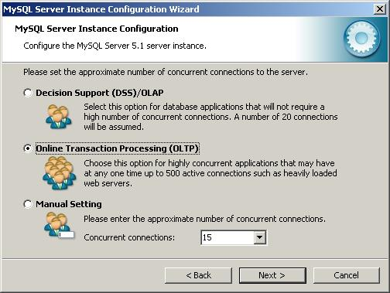

**7. Set networking options.**

By default, make your selection the same as screenshot below. If port 3306 has been used by another instance of MySQL server, you can select port 3307 or a different port. This will allow [two instances of MySQL server to be accessed via different ports on the same box](http://www.geeksengine.com/article/connect-to-two-mysql.html).

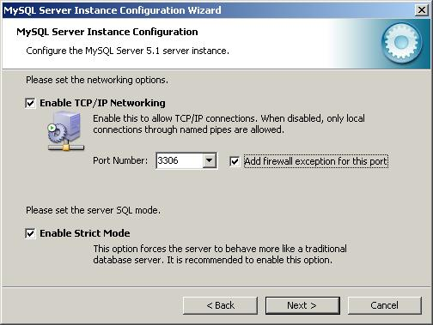

**8. Select the default character set.**

By default, the Standard Character Set is selected, but you may want to select the second option - Best Support For Multilingualism. This allows our database to store text in many different languages.

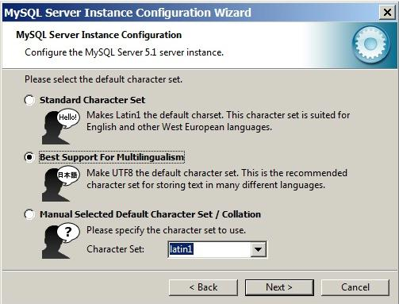

**9. Install MySQL server as a Windows service.**

Below is the recommended way to run MySQL server on Windows. Making the service name as MySQL51 clearly identifies the service as a MySQL server version 5.1 database engine because you might [install other versions of MySQL server on the same machine](http://www.geeksengine.com/article/install-two-mysql.html).

You might also want to check Include Bin Directory in Windows PATH if you want to operate MySQL from command line.

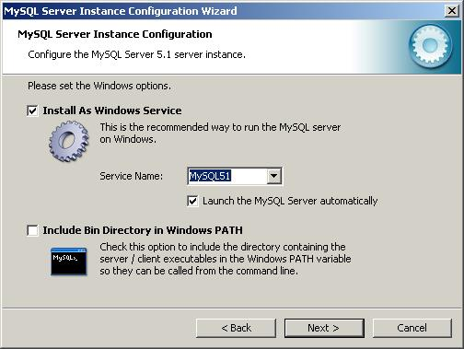

**10. Set the root password.**

Set a new password to the root account. Enter the same password to all three boxes. See below.

Don't select the Create An Anonymous Account checkbox. This can lead to an insecure system.

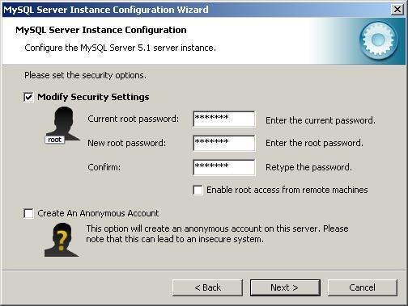

**11. Ready to execute the configuration.**

Now everything is ready to execute. Click [Execute] button.

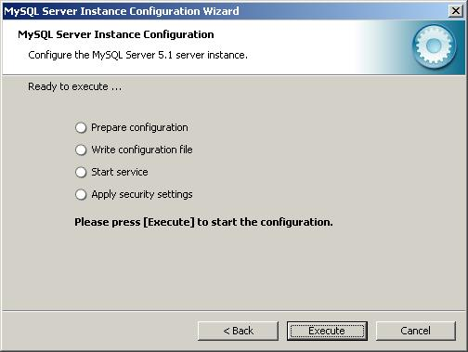

**12. Configuration successfully completed.**

The configuration file has been created successfully. Click [Finish] to close the wizard.

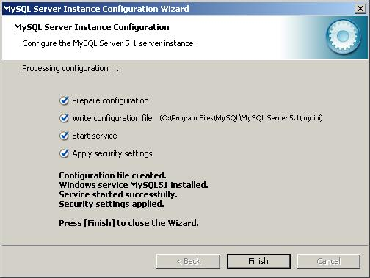

**Create database:**

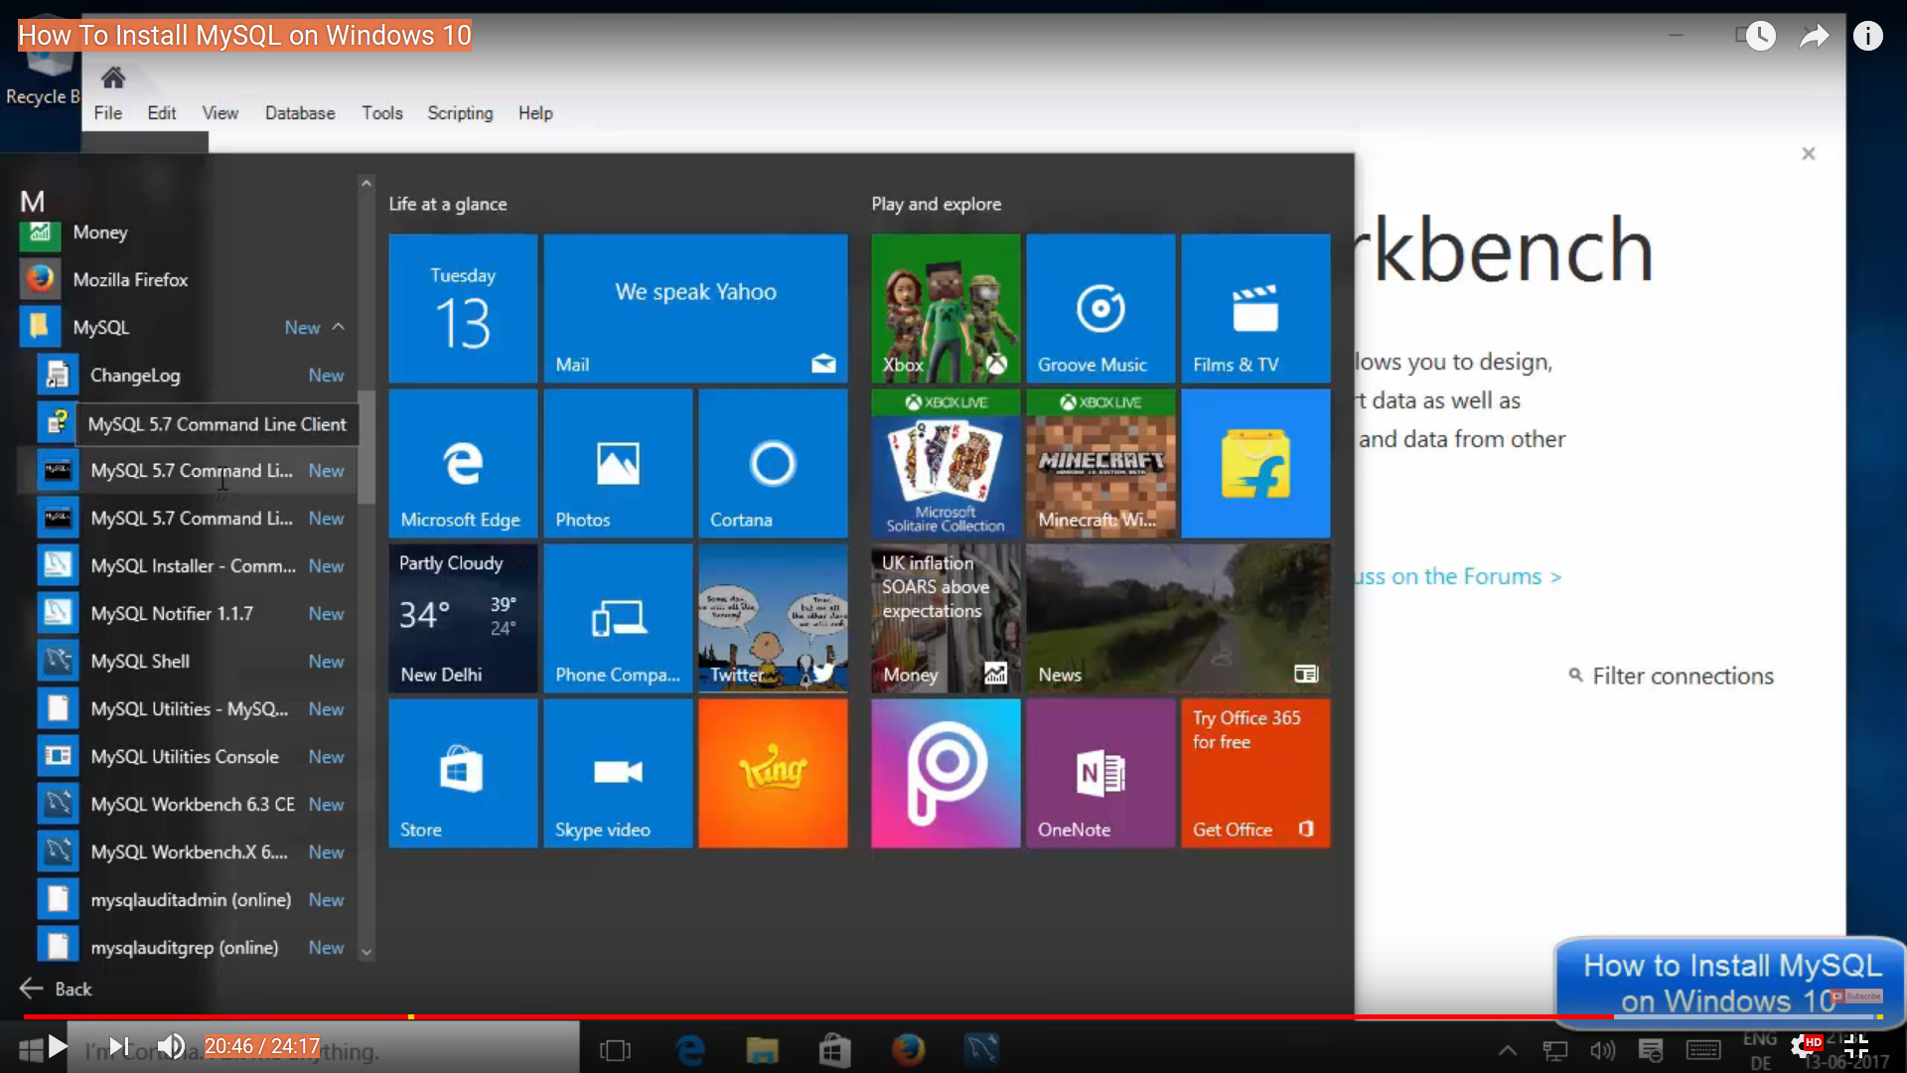

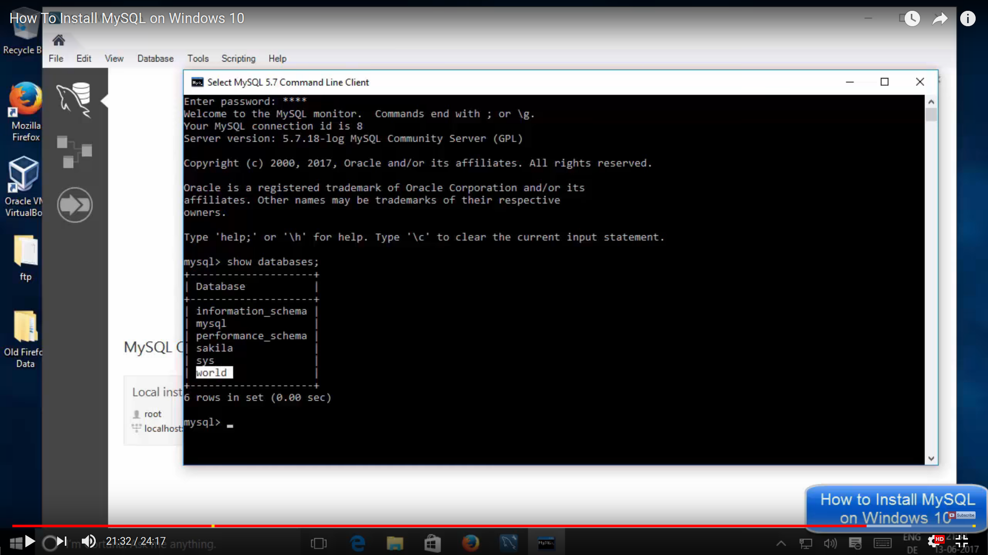

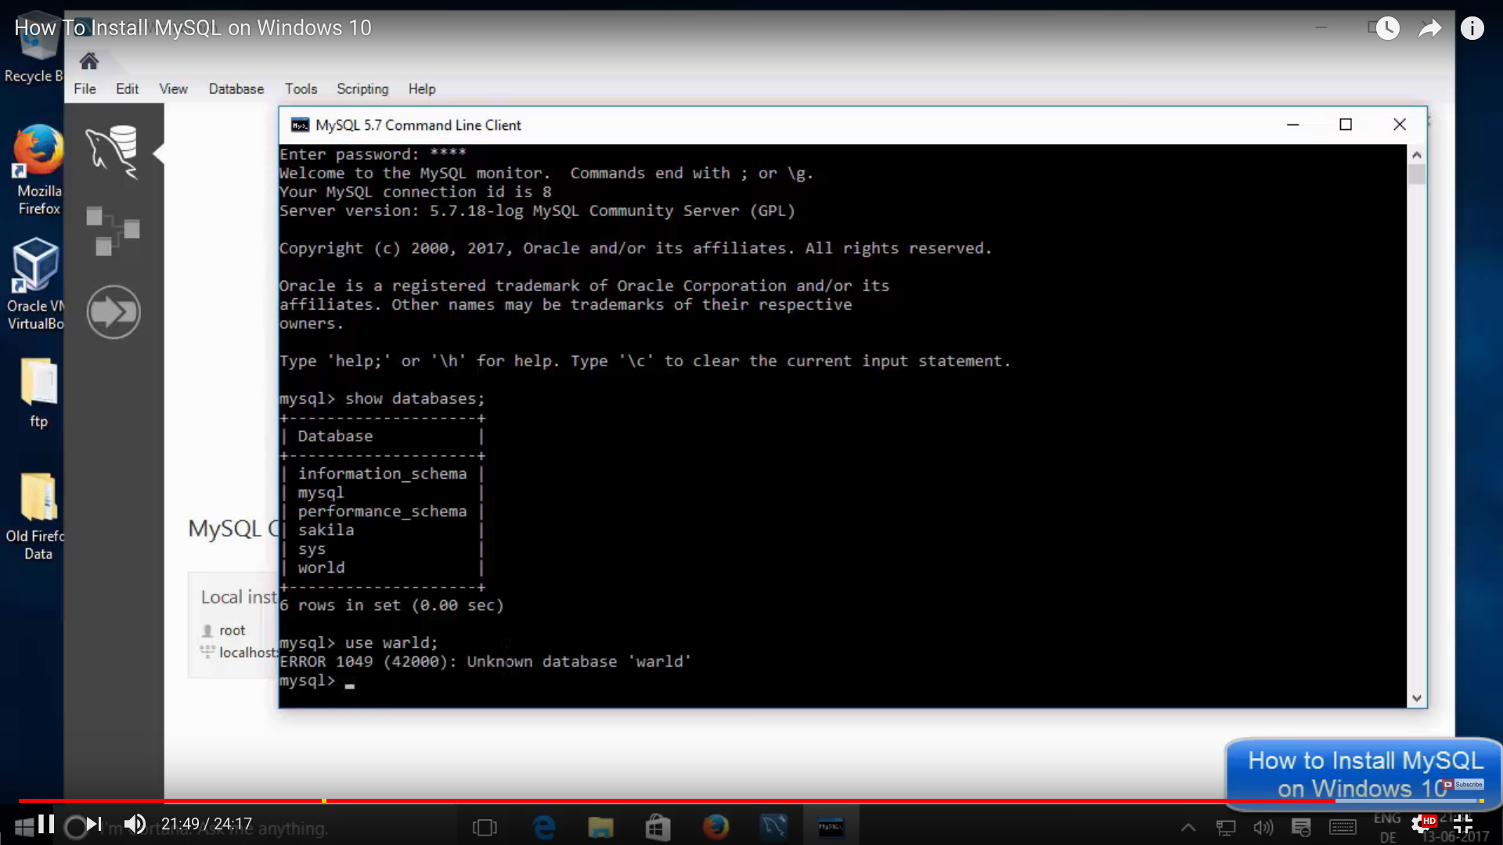

You need to type in your cmd terminal

**mysql>create table name foods(Fullname varchar(99),Username varchar(99),Password**

**varchar(99),sec_Q varchar(99),Answer varchar(99));**

**The table created**

**Check:**

**mysql> select * from foods;**

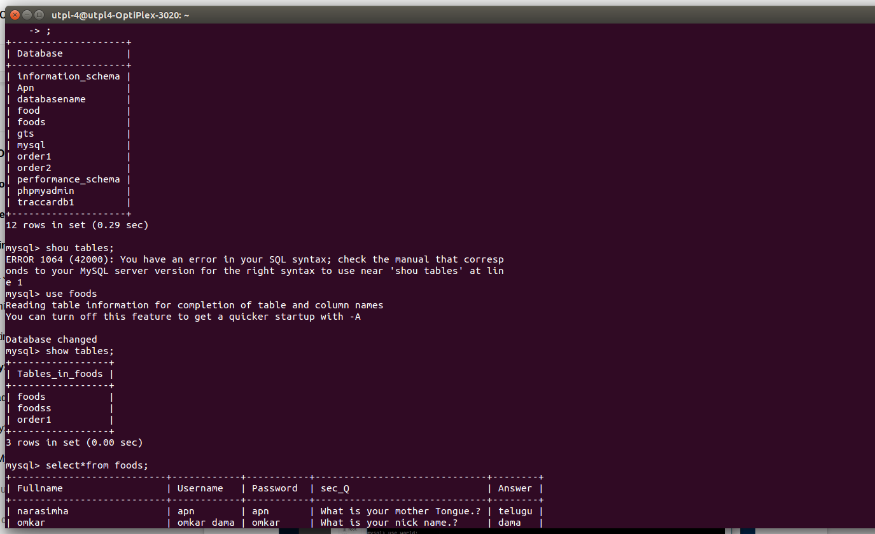

7 Food court ordering system

#### 

#### 

#### **Introduction**

Developing an 7 Food Court Ordering system to promote a greater count of food lovers to splurge into the field of Restaurant was the objective of this study. This particular system provide the benefit of the easy ordering process online from anywhere along with ample choices for the customers in less time and less expenditures. This latest effort will definitely usher an edge in the existing manual platform used so far for such an important aspect along with greater flexibility and sophistication in the use of the technology. The system also aided E-ordering option for the customers with multiple other benefits

The user should register in the system to avail the utility. Users will be able to select their preferable food items from the existing E-menu card and order their requirement online. User will receive an onscreen presence of the selected items immediately after item selection. Application of this system will reduce the additional service associated manpower used in the hospitality industry, thus may provide financial benefits to the owners of such industry. Moreover, this system will be useful during the rush hours in the food courts when waiters or other service providers remain busy and unavailable to all the customers at a time. The user will have a username and a password for their regular use and personalised account maintenance.

#### **Food court Ordering System**

So far, the traditional service system in the restaurant industry follows huge paperwork and human labour which may not be sufficient with the ever-growing demand in quick service in the industry. On the other hand, manual maintenance of the crucial information in papers are tedious and risky certain times. This system is developed as a complete framework which demonstrates stage by stage information from procuring materials to preparing an online

Due to enormous busy schedule and concentration on professional and personal work, the present generation is not willing to waste time in a queue of a restaurant, be it for occupying a place or receiving the ordered menu. Working and student community gathers in restaurants during their break time which is limited, therefore, they do not prefer to wait in a queue for any reason. This tool will help such kind of customer to save their valuable time by ordering their food without any manual interference and delay. The following objectives were considered while designing the project:

• Ordering food within limited span of time without any interference.

• Providing more convenience and choices to the customers.

• Automated order and billing system.

**Problem Statement**

Today, many food courts still using the traditional way to make customer order, as we can see in the traditional service that use today is the waiter takes customer order by pen and paper. This is a not efficiency method, inconvenient and may contain mistakes. For example, if the waiter lost his order paper in the hustle or the waiters writing is hard to understand, that may cause the kitchen and cashier mess up the orders also may cause calculation errors.

By using Food Court Ordering System Using Mobile Application, it makes the service more efficiency and can help the manager to avoid human error and enhance the business development. In this system, the ordering transaction is a step by step model to make the transaction more systematic and the system can guide the staff to avoid errors. Beside the efficiency service, by using this system it can gave a better quality service to customer and it will attract more customers to the food court to get this quality of service.

**Objectives**

The main objectives for the development of Food Court Ordering System Using Mobile Application are:

I. To computerize the ordering system so that it can make the transaction more

systematic.

II. To avoid misuse errors such as waiter lost his order paper or the waiter’s handwriting is hard to understand.

III. To save all the transactions into the database and using that database manager can know all the transaction that has been made.

IV. To apply mobile application such as smart phone, wireless etc for all data acquisition.

**Scopes**

The scopes of this project are:

I. The scope of this project is for the large food court that used centralized management of operation.

II. The module includes ordering, cooking status, payment and administration.

III. This system will be used by waiter, stall cooker, cashier and manager.

IV. Administrator (manager)

* Control all system activities.
* Delete, update and search all data in the system.
* View all data in the system.

V. Users (waiters)

* Takes customer orders.
* Checking food status

VI. Cashier

* Calculate customer billing
* Print a receipt

VII. Hardware

* Wireless Router (Wifi)
* Smart phone
* Laptop (PC)

Procedure:7 Food court ordering system

Login screen

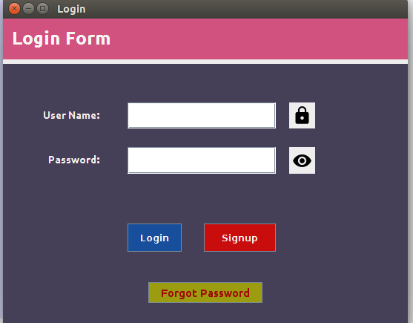

In [computer security](https://en.wikipedia.org/wiki/Computer_security), logging in (or logging on or signing in or signing on) is the process by which an

individual gains [access](https://en.wikipedia.org/wiki/Access_control) to a [computer system](https://en.wikipedia.org/wiki/Computer_system) by [identifying](https://en.wikipedia.org/wiki/Proof_of_identity) and [authenticating](https://en.wikipedia.org/wiki/Authentication) themselves. The [user](https://en.wikipedia.org/wiki/User_(computing))

[credentials are](https://en.wikipedia.org/wiki/Credential) typically some form of "username" and a matching "password",

After successfully compilation we can see the login window

In this login form functionalities are firstly it provides the “UserName” and “Password” for authenticating.

Click login for authenticating and click signup creating new account and if you forgot the password click on forgot password.

* Firstly we need to create an account for that click signup ↵
* It will show one more screen for signup see in below.

Create Account:

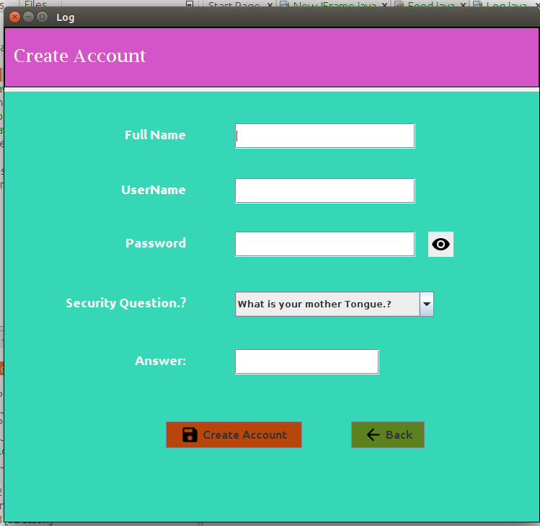

* Here you need to create an account and the user functionalities are “fullname”, “Username”, “Password” and show password and “security Question” and “answer” and click create and goto back
* After that enter the username and password . it is successfully validation means you will go to another screen otherwise you will get one popup error window.
* If you forgot the password click on forgot password you will get like below window.

Forgot Password..?

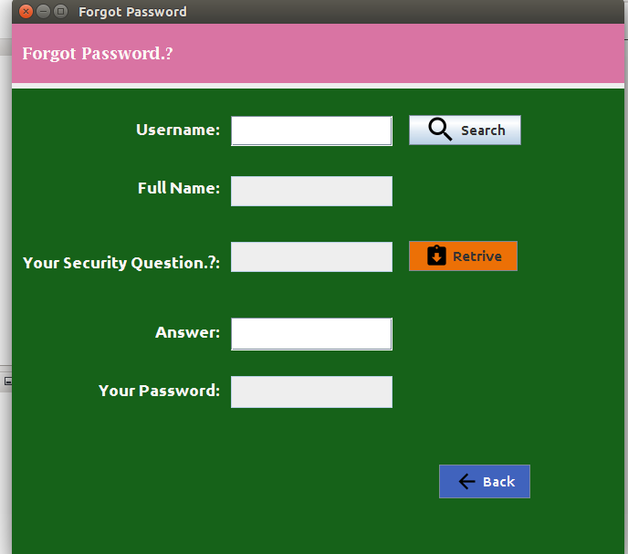

Here we you need to enter your username after that click on search button your

full name and our security question. Is automatically redirected. And we need to give an answer.

And click the retrieve button you will get your password. And click back.

Loading:

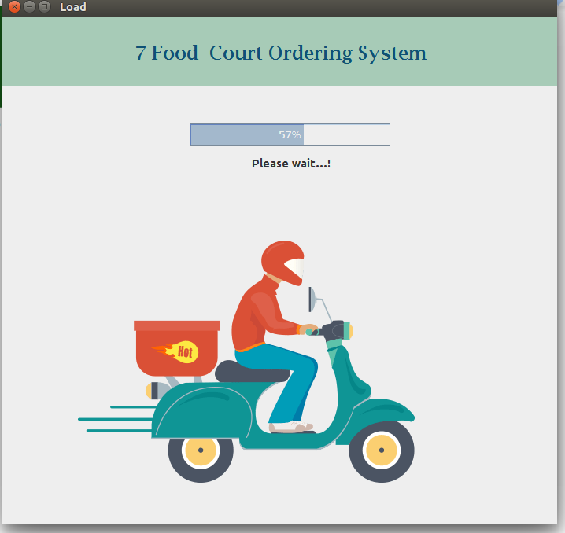

* Here after successfully login the loading will start. After that you will goto main account like as shown in below.

Main Account:

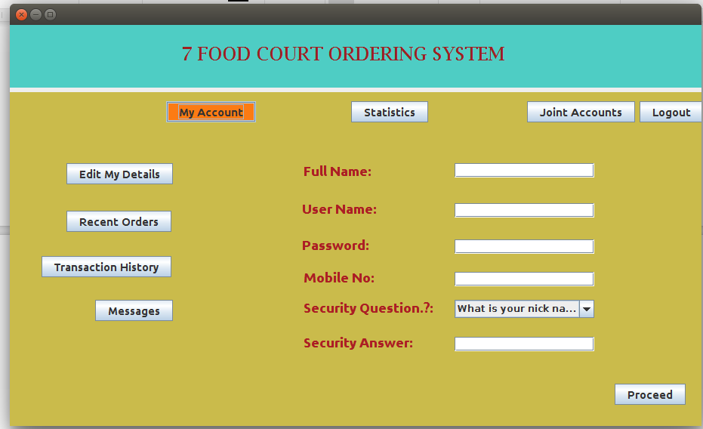

Here you want edit your details. And we need to for a logout and some more buttons you can see for checking our past data. After that click proceed. You need to get one more screen for order the food.

Food Order:

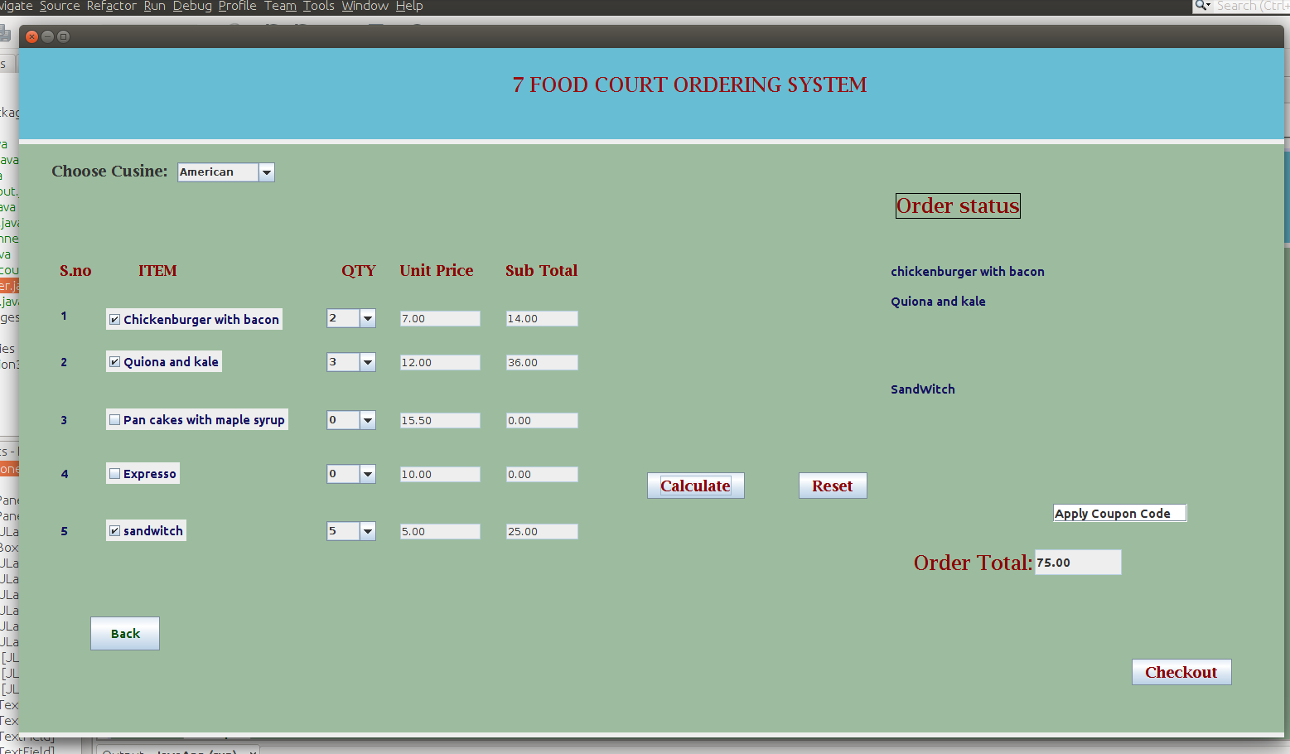

* Websites featuring online restaurant menus have been on the Internet for nearly a decade. In recent years, however, more and more restaurants outside of large metropolitan areas have been able to feature their menus online as a result of this trend.
* Several restaurant-owned and startup [online food ordering](https://en.wikipedia.org/wiki/Online_food_ordering) websites already included menus on their websites, yet due to the limitations of which restaurants could handle online orders, many restaurants were left invisible to the Internet aside from an address listing. Multiple companies came up with the idea of posting menus online simultaneously, and it is difficult to ascertain who was first. Menus and online food ordering have been available online since at least 1997. Since 1997, hundreds of online restaurant menu web sites have appeared on the Internet. Some sites are city-specific, some list by region, state or province.
* Here you can order the food as you like either go for american or chinese or south indian and you need to select how much quantity you want and click on calculate button it will shows the amount for each and and total you need to change the order just click on reset.
* After successfully select the food click on checkout in that you need to give the address and card details .

Here we need to enter the details of the customer

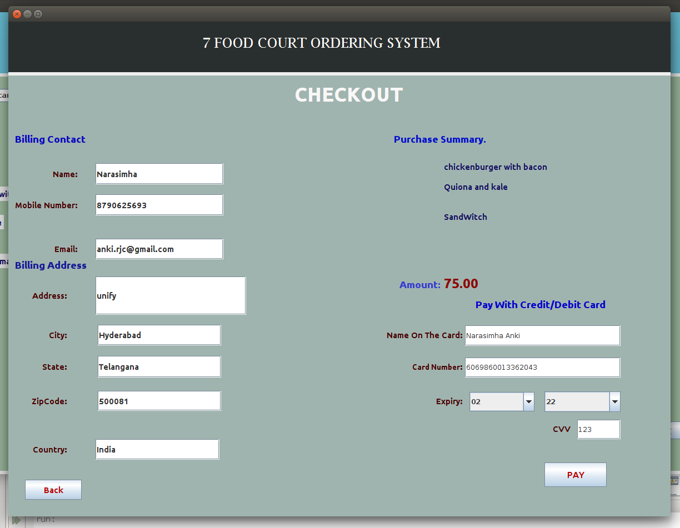

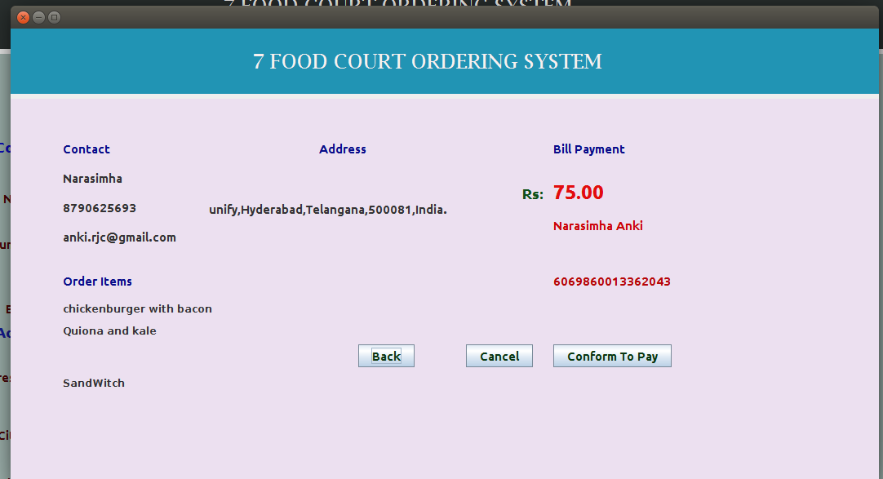

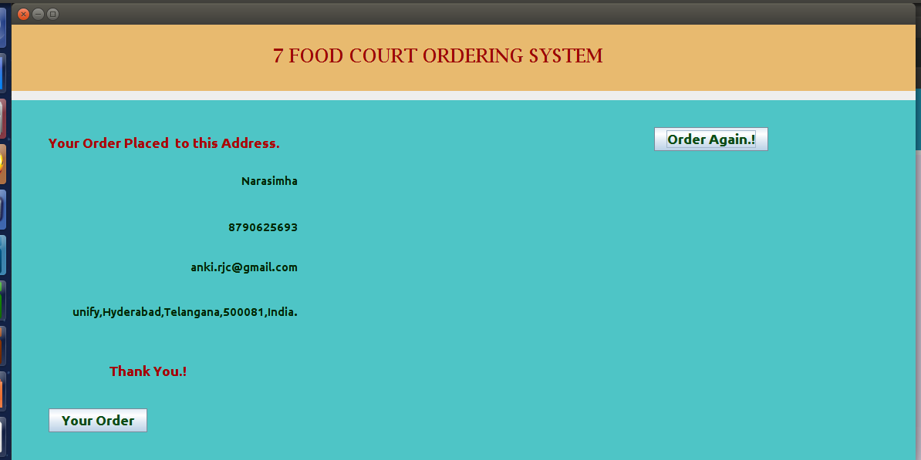

Total bill payment debited from customer

Fig:order place to this Address